This is histogram for ODE task, there is a comparison of libraries Adept and XAD solving this task.
The results can be two types, ode::primal and ode::gradient:
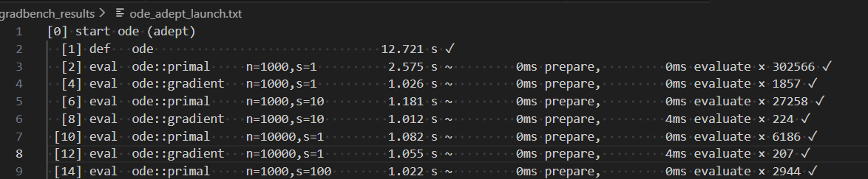
ode::primal – is a calculation of function value, it solves the ordinary differential equation (ODE) using the Runge-Kutta method.
ode::gradient – it calculates the derivatives (sensitivities) of the output with respect to the input – the actual benchmark.
This is an uniform distribution which represents the number of tests for every time difference with a step of 0.05 seconds:
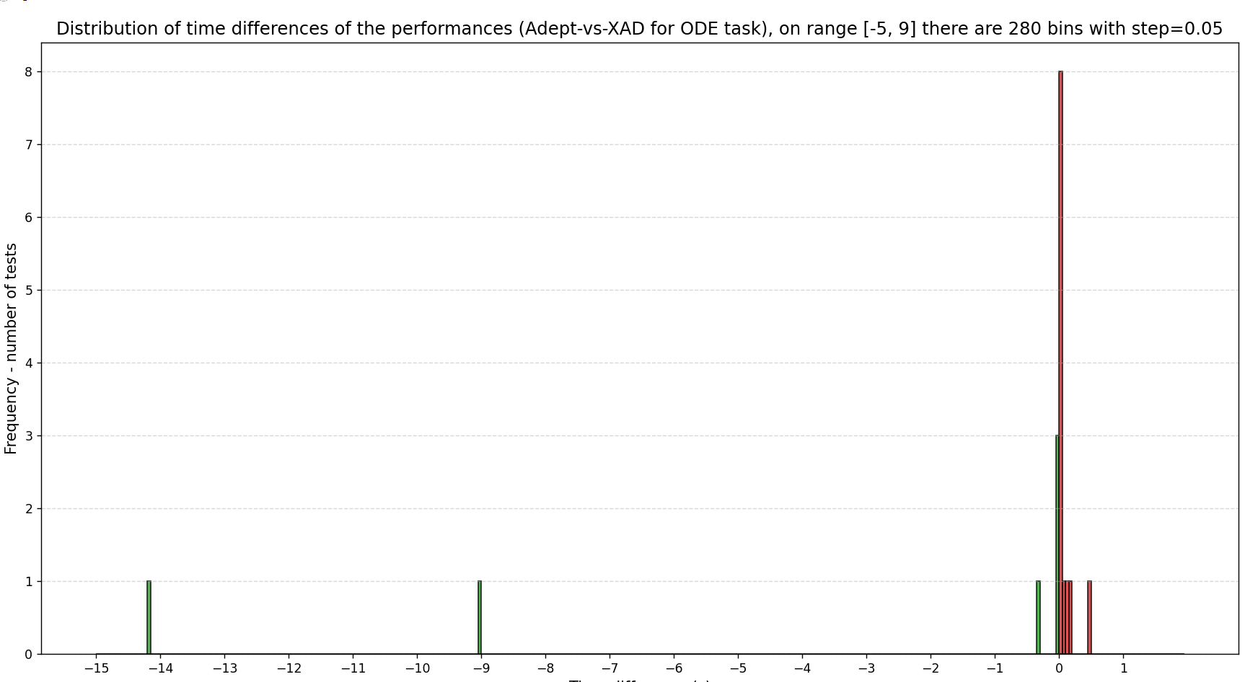
This is a distribution which includes only information with differences up to 0.5 seconds:
it seems the most representative plot for this test, because almost all the time differences are in a range [-0,5; 0,5]
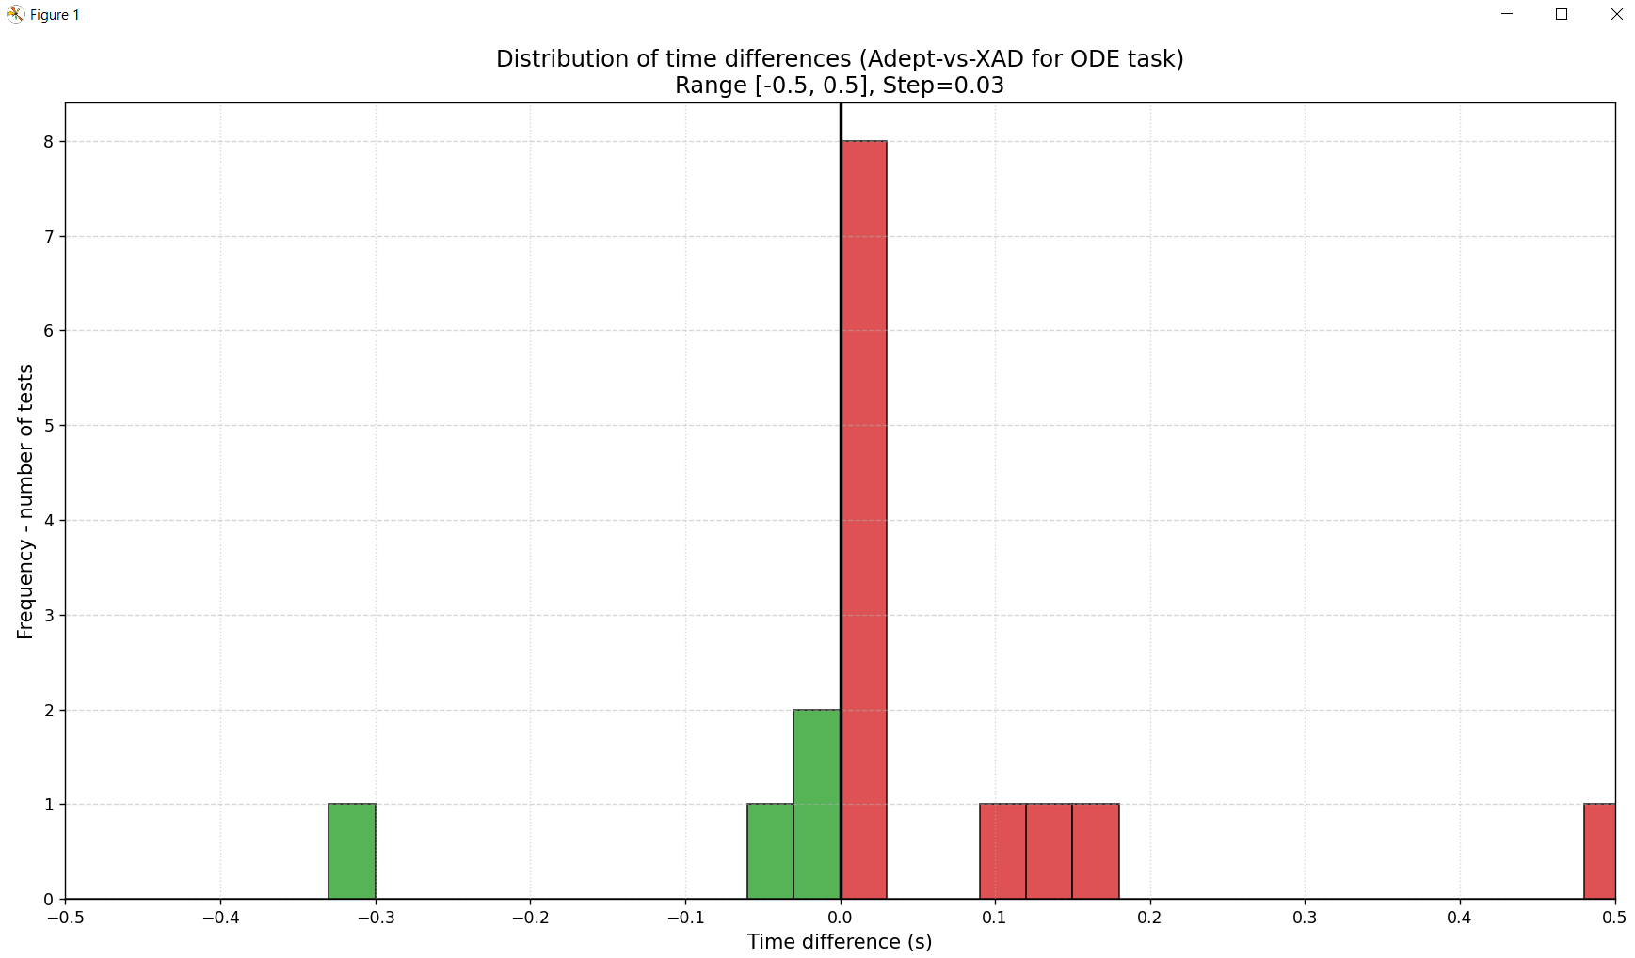
The non-uniform distribution is not useful here because most of values are between -0.5 and 0.5 so it is not representative:
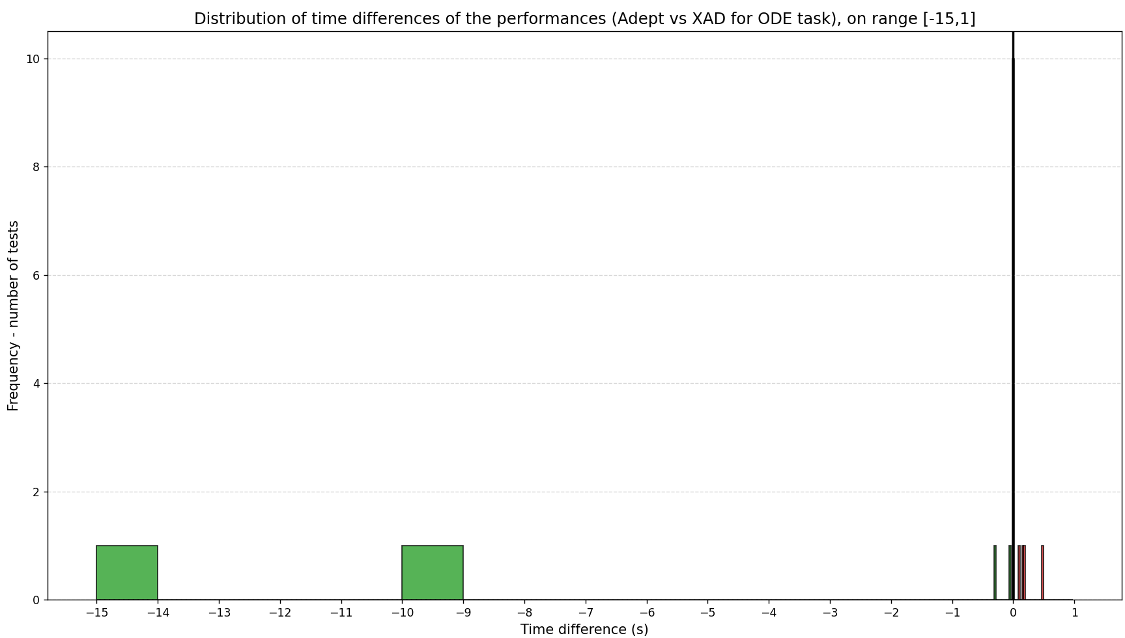

I created an implementation of LLSQ (linear least squares) for Grandbench benchmark and compared it with Adept implementation for solving this task
This is an example of the results I got for XAD library for LLSQ task:
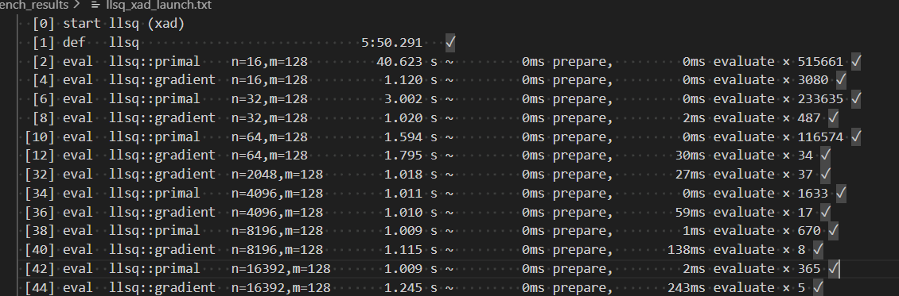
llsq::primal – is a calculation of function value – the sum of squared errors, without any differentiation.
llsq::gradient – it calculates the result plus the gradients (derivatives with respect to parameters) – the actual benchmark. It measures the overhead (loss of the performance) of recording the computation graph and performing the reverse pass.
This is a uniform distribution which represents the number of tests for every time difference with a step of 0.05 seconds:
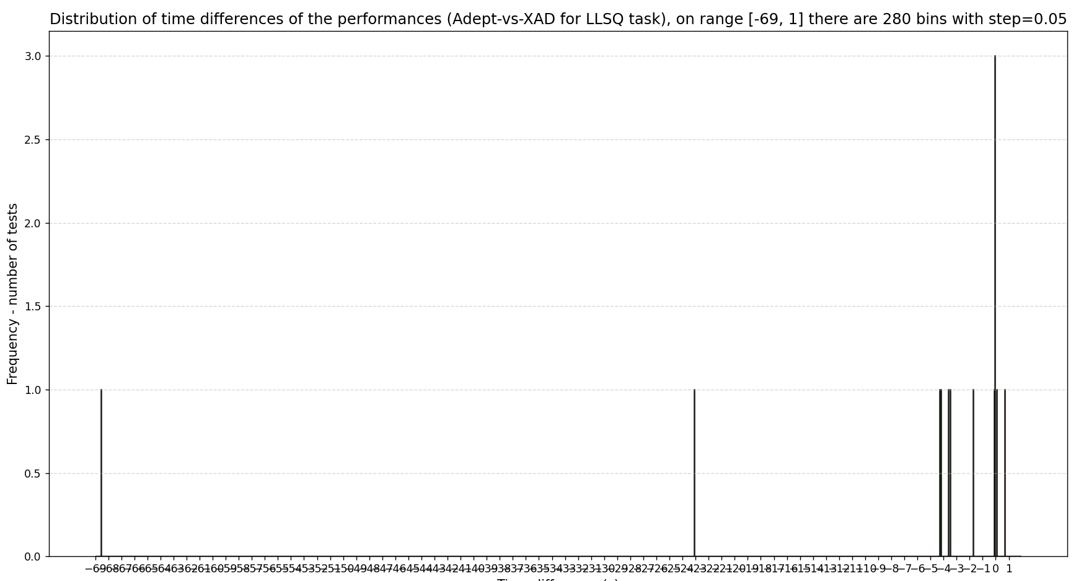
It shows that there is a very big time difference in one of the calculations – 69 seconds. But most of the time difference is not more than 5 seconds.
There are many values in range [-0,5;0,5] so it would be more useful to look for this interval, it can be shown on this histogram:
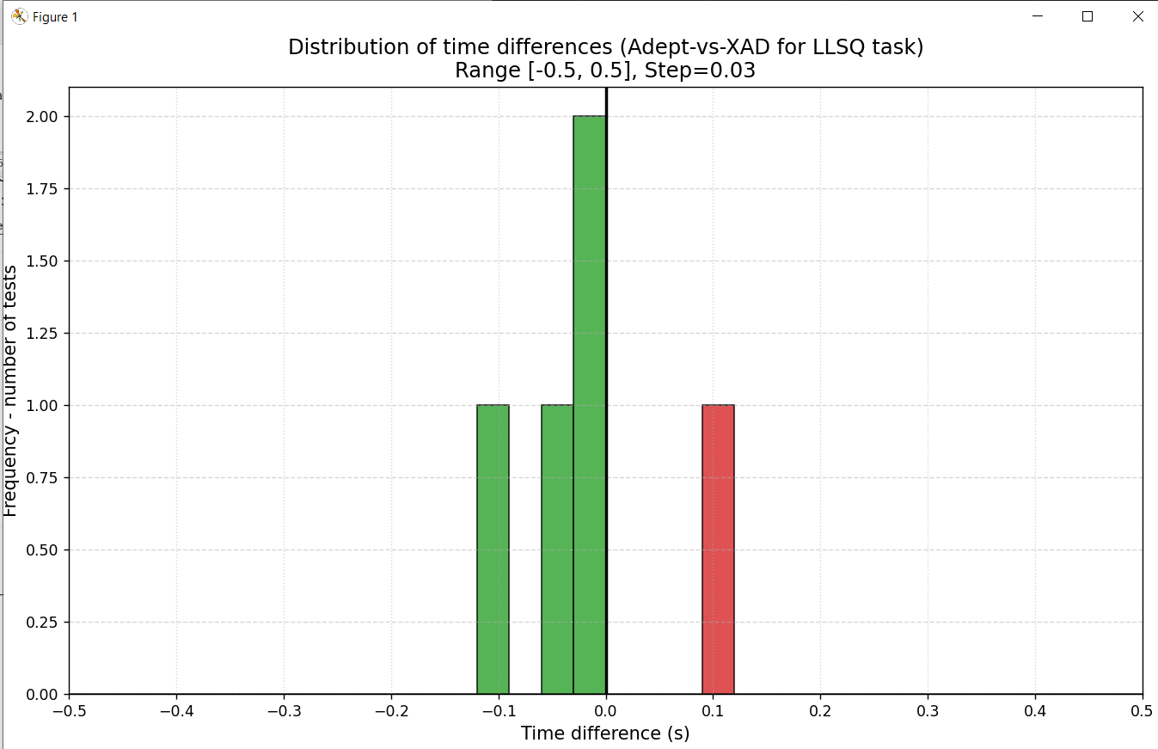
It can be seen that the in this range in most of cases XAD is faster than Adept in solving LLSQ task, there is only one test when Adept is faster.
To make a histogram more representative, we can create a histogram with a range [-6;1] :
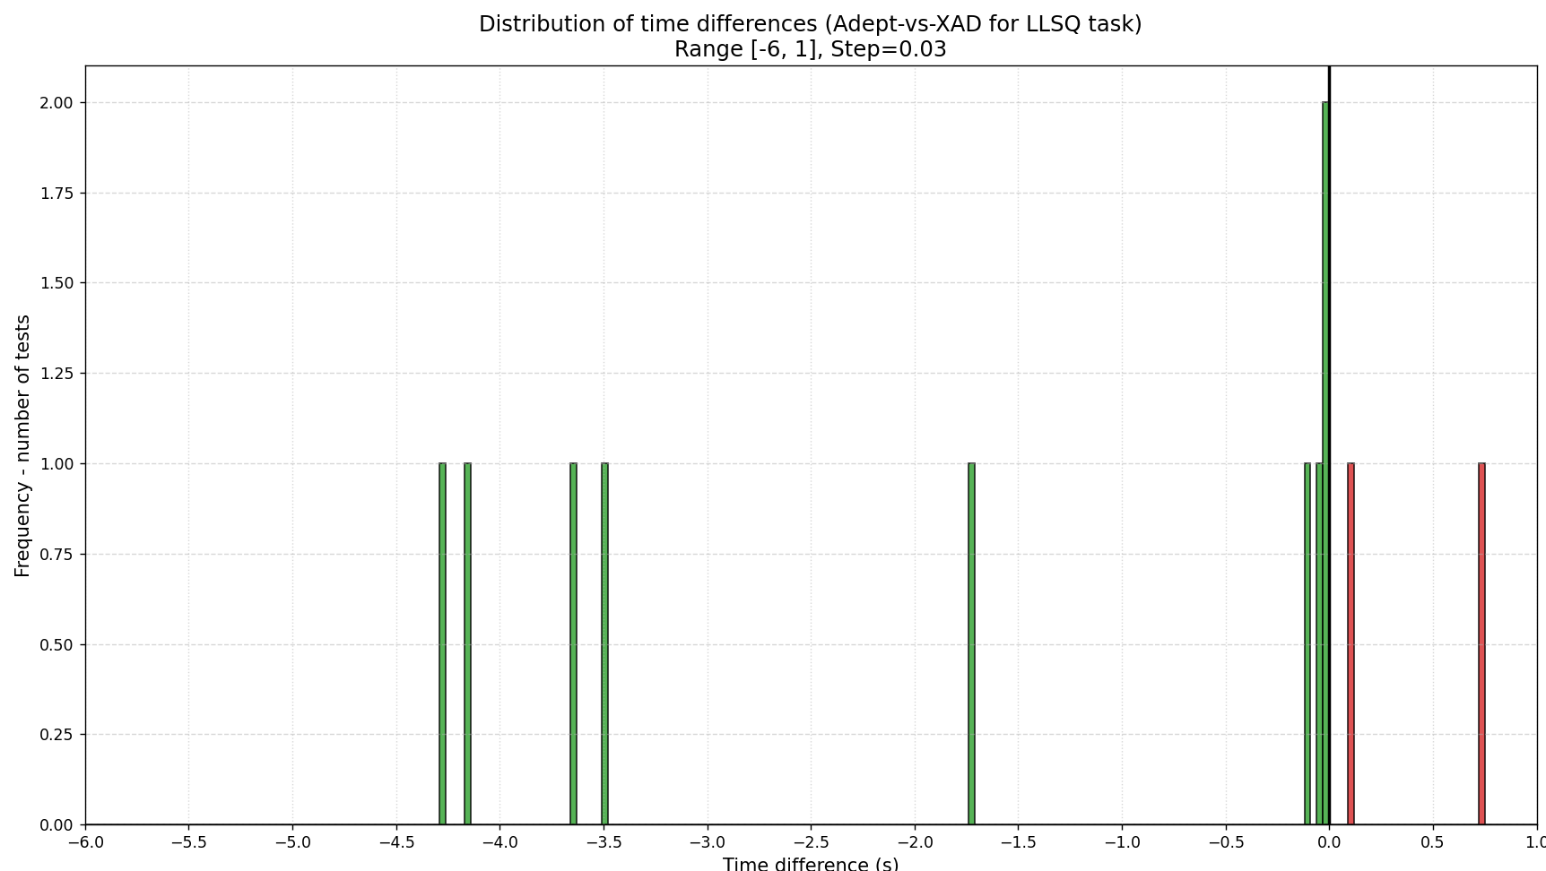
We can see that there only 2 tests when Adept is faster than XAD, in all other cases XAD is faster than Adept, in most of cases the difference is up to 5 seconds.

I created an implementation of DET (Determinant Using Expansion by Minors) for Grandbench benchmark and compared it with Adept implementation for solving this task
This is an example of the results I got for XAD library for DET task:
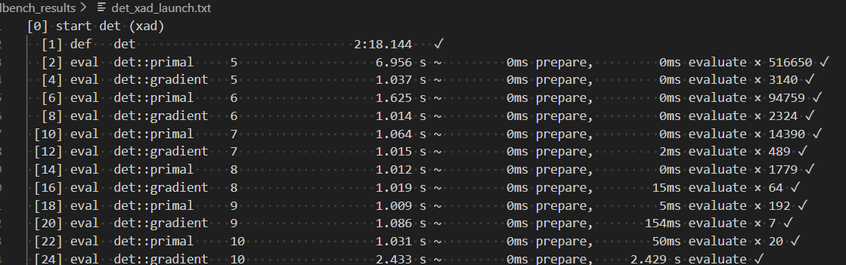

This is a uniform distribution which represents the number of tests for every time difference with a step of 0.05 seconds:
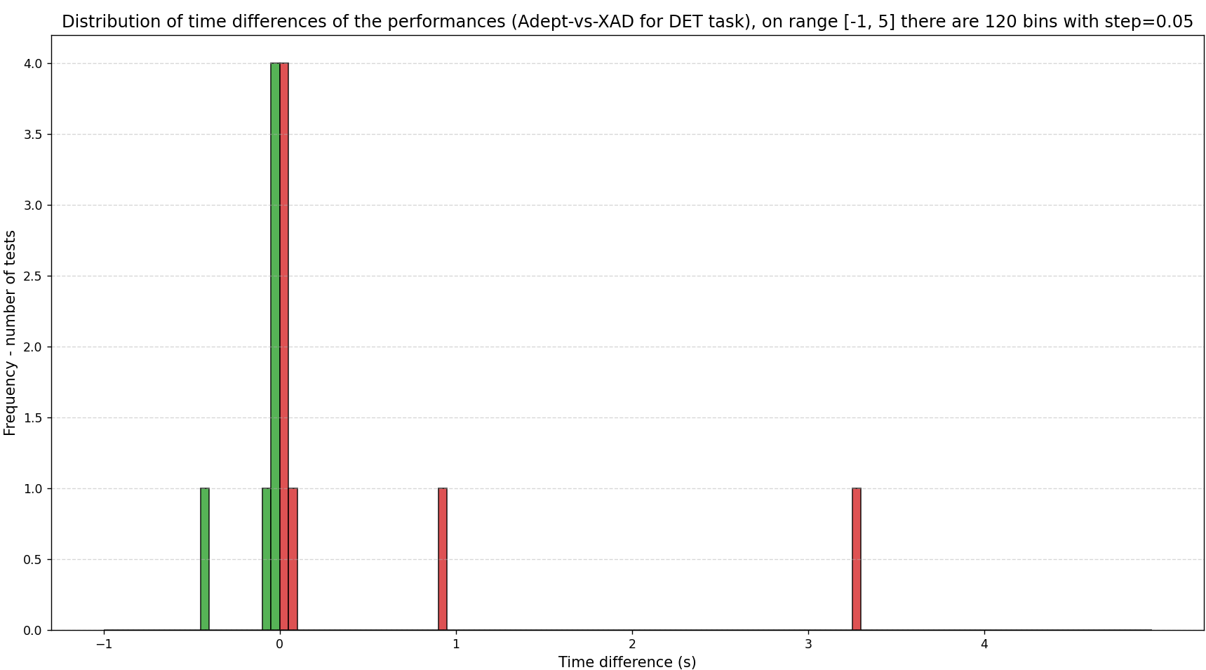

As in previous cases, the majority of values are in the range [-0,5;0,5], there is a histogram which represents this range:
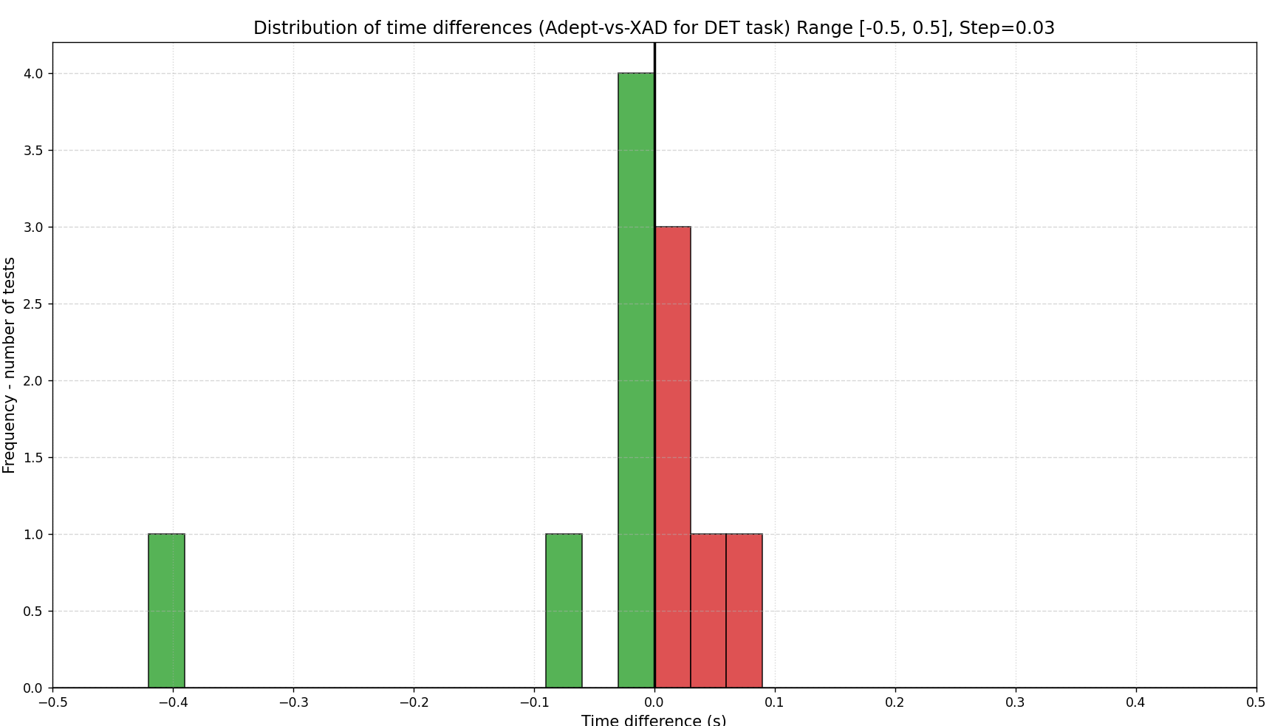
Overall, there are 7 cases when Adept is faster than XAD in DET task, and 6 tasks when XAD is faster. In this task the performance of both tools is relatively the same.

